[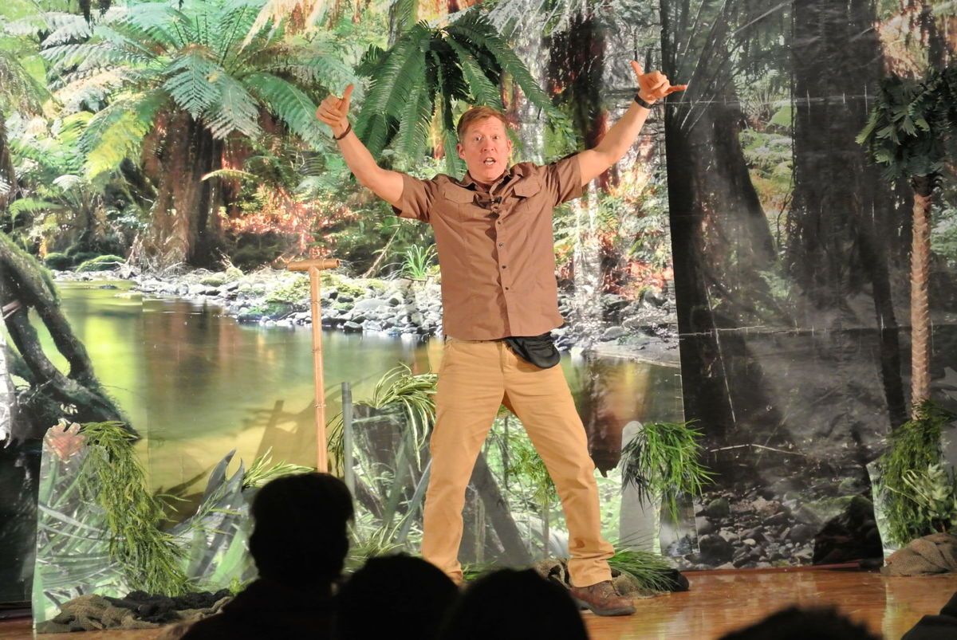](http://www.timesjournal.com/content/tncms/live/#3)[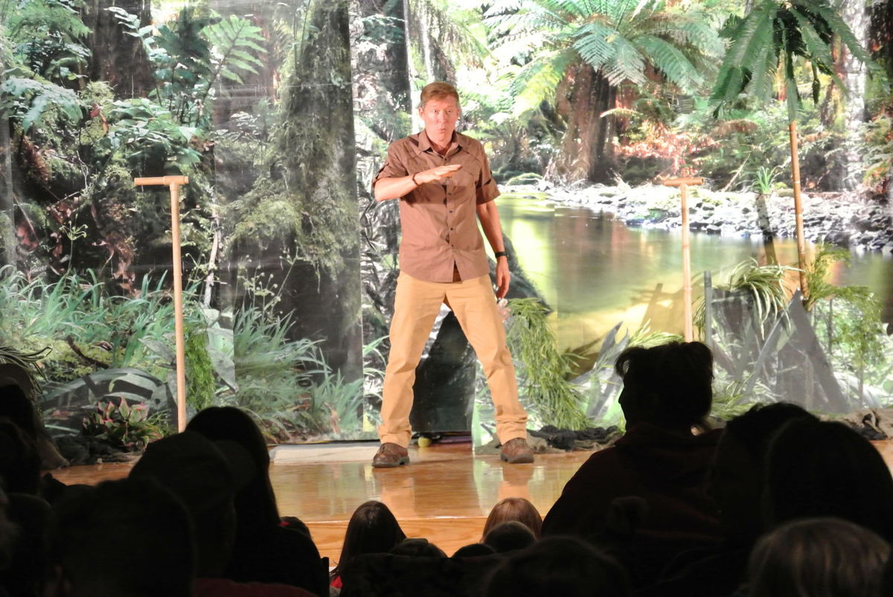](http://www.timesjournal.com/content/tncms/live/#2)

[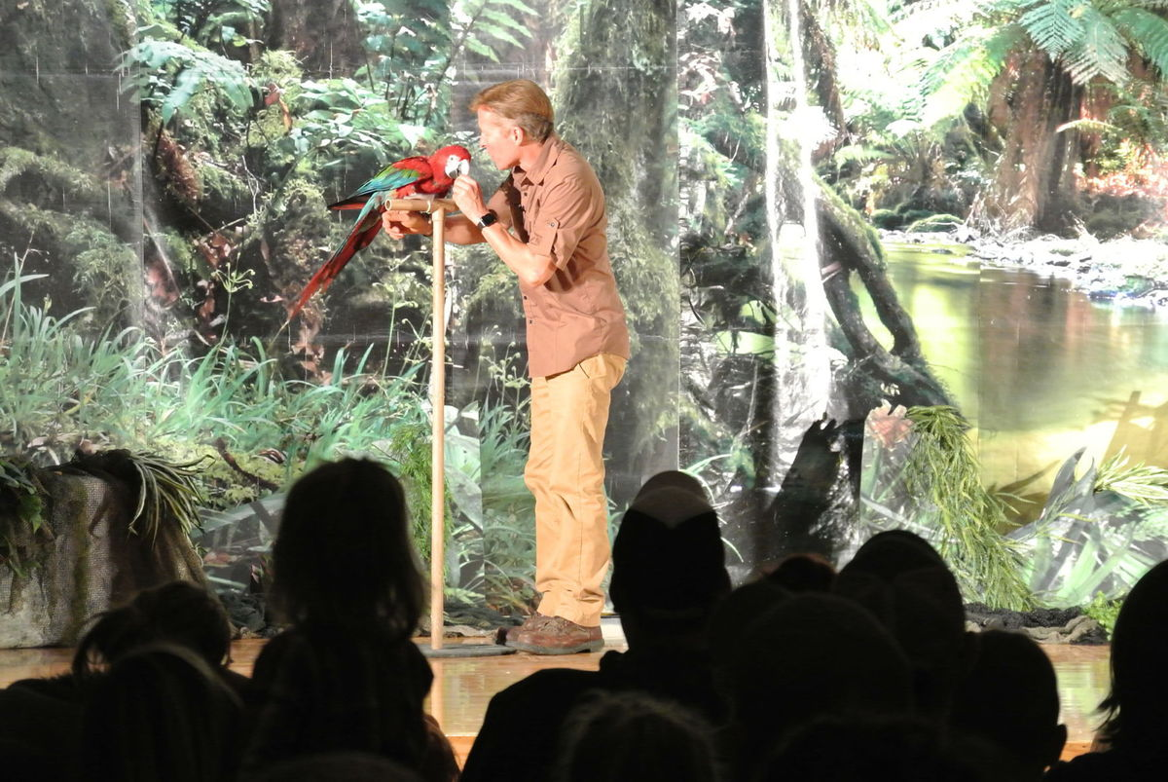](http://www.timesjournal.com/content/tncms/live/#7)[](http://www.timesjournal.com/content/tncms/live/#5)

[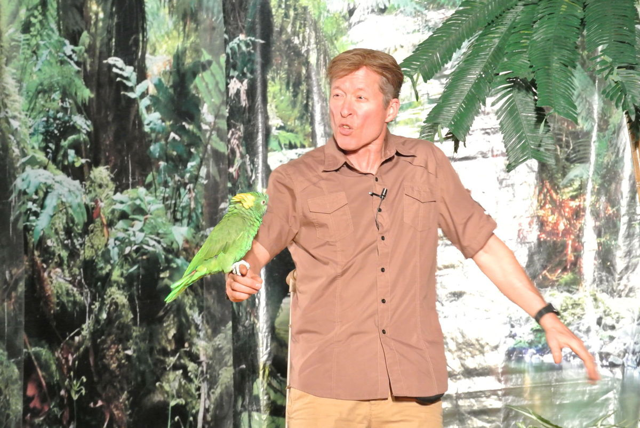](http://www.timesjournal.com/content/tncms/live/#10)[](http://www.timesjournal.com/content/tncms/live/#7)

[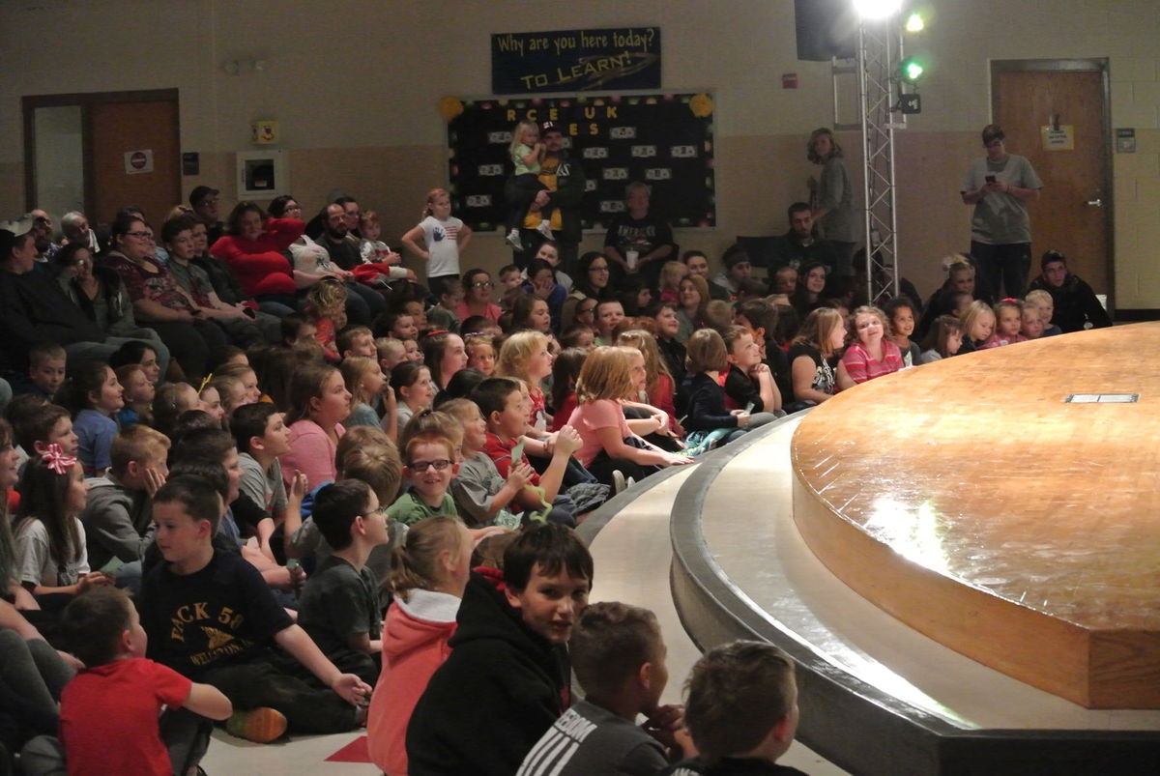](http://www.timesjournal.com/content/tncms/live/#12)[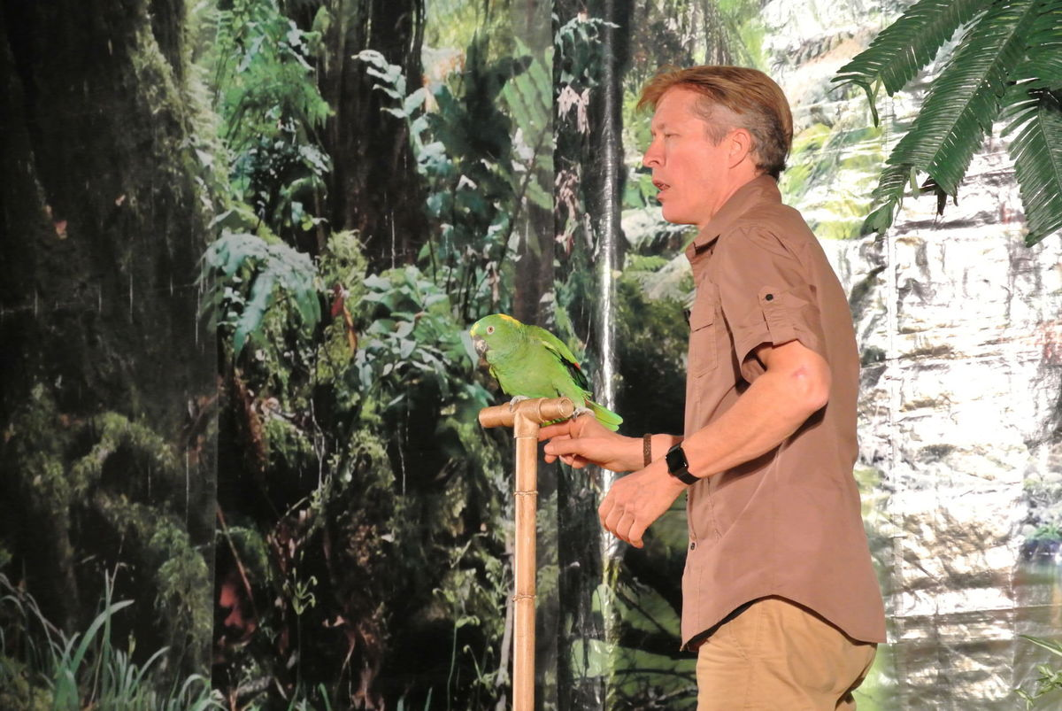](http://www.timesjournal.com/content/tncms/live/#11)

[](http://www.timesjournal.com/content/tncms/live/#17)[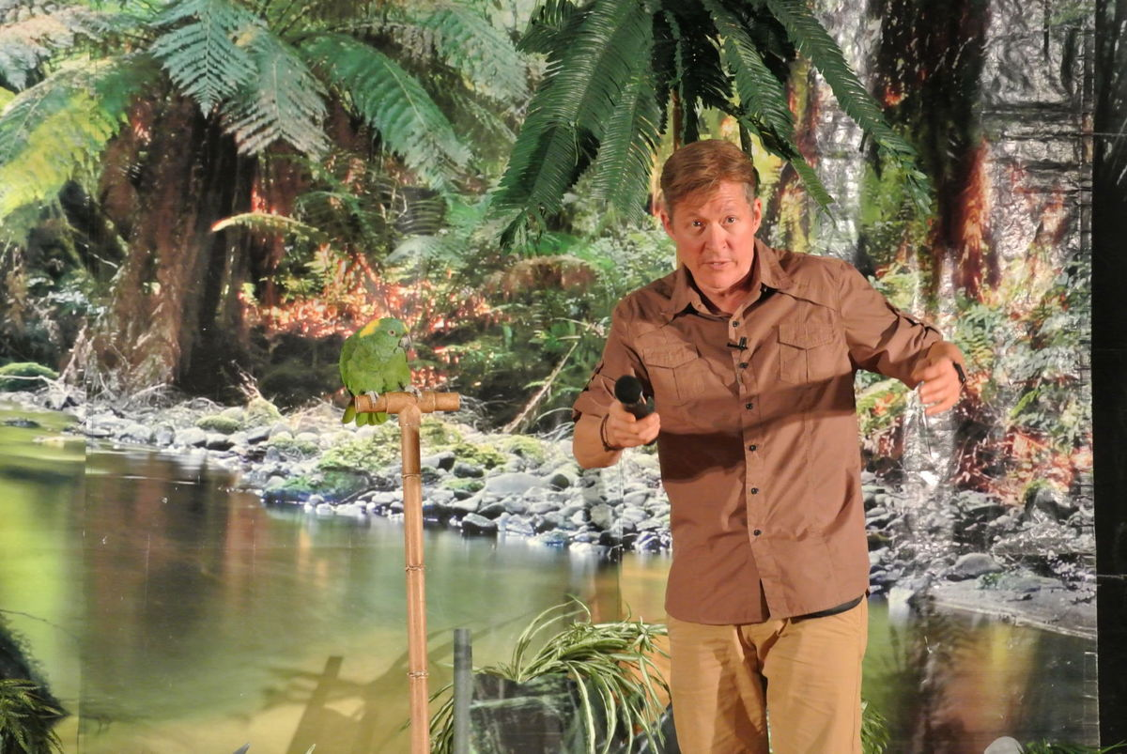](http://www.timesjournal.com/content/tncms/live/#14)

[](http://www.timesjournal.com/content/tncms/live/#17)

[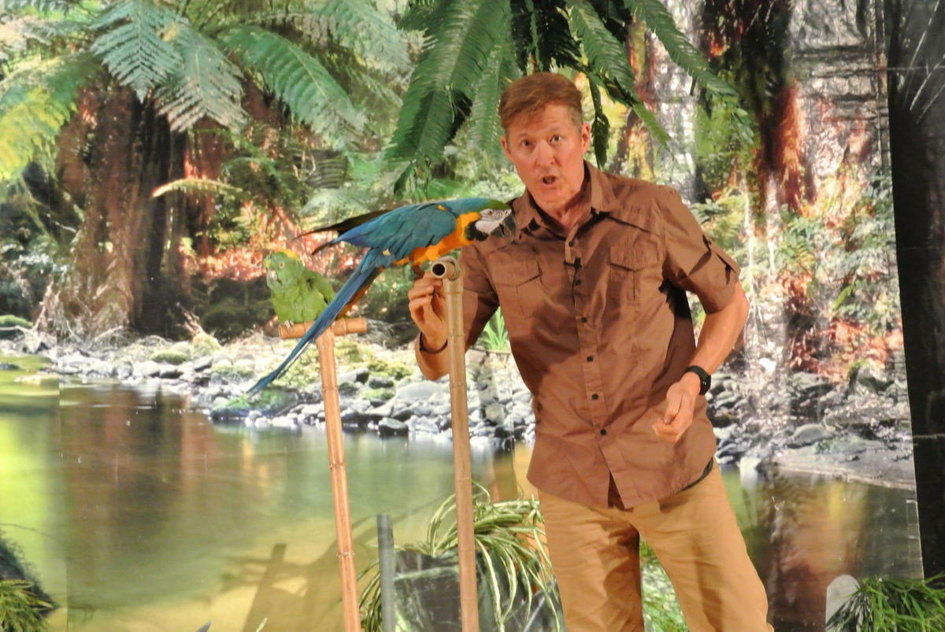](http://www.timesjournal.com/content/tncms/live/#15)

[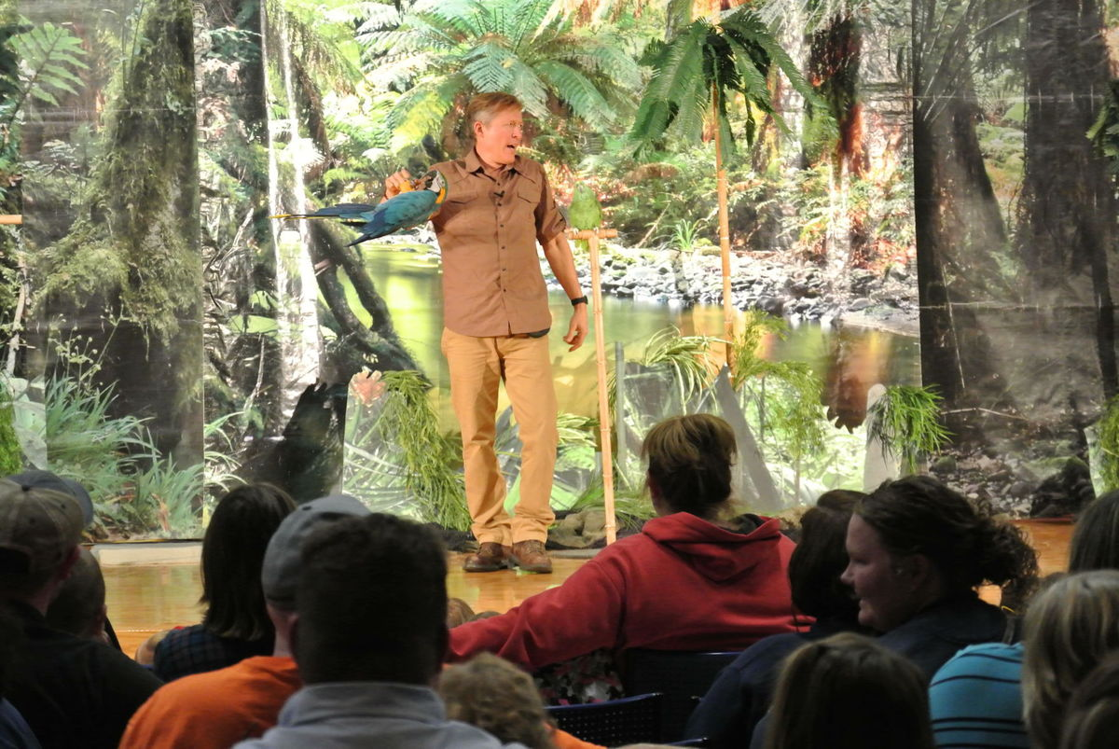](http://www.timesjournal.com/content/tncms/live/#19)[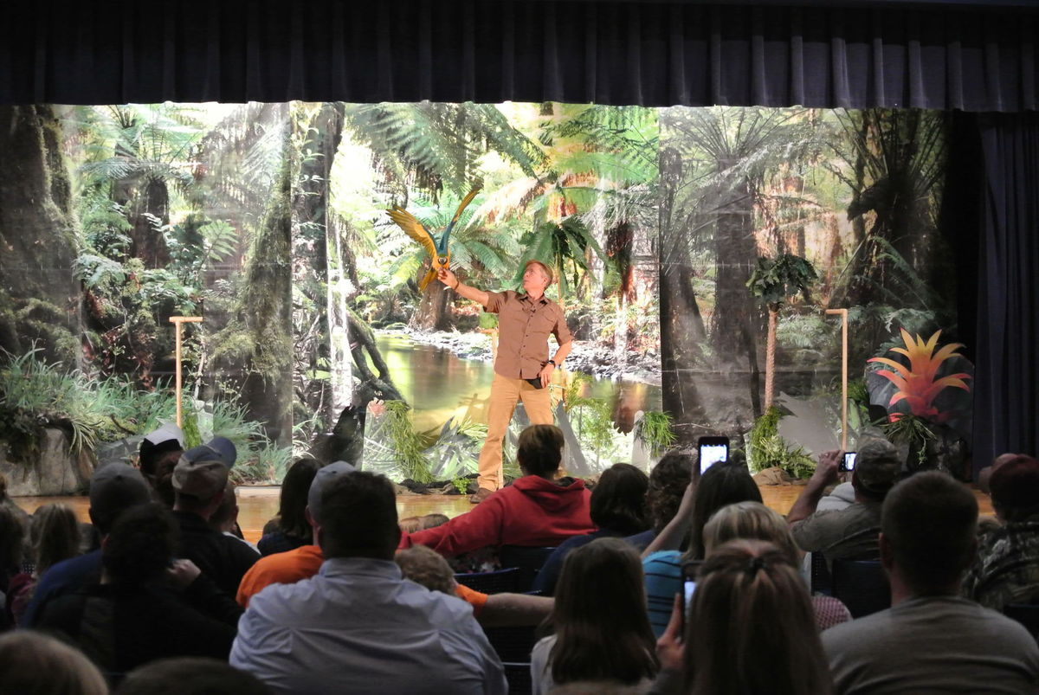](http://www.timesjournal.com/content/tncms/live/#18)

[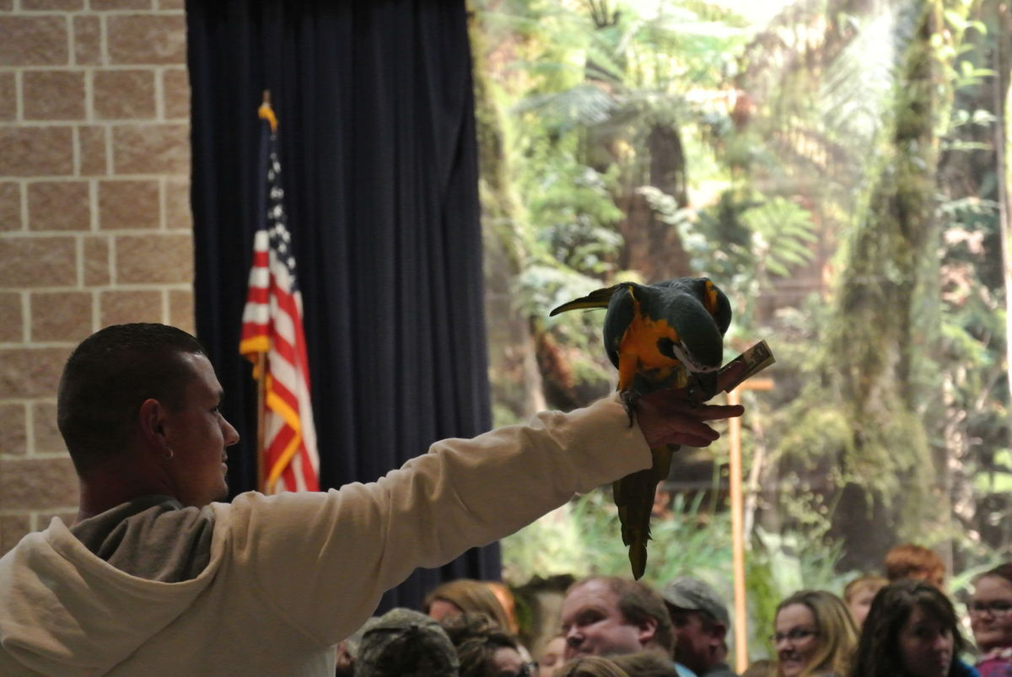](http://www.timesjournal.com/content/tncms/live/#22)[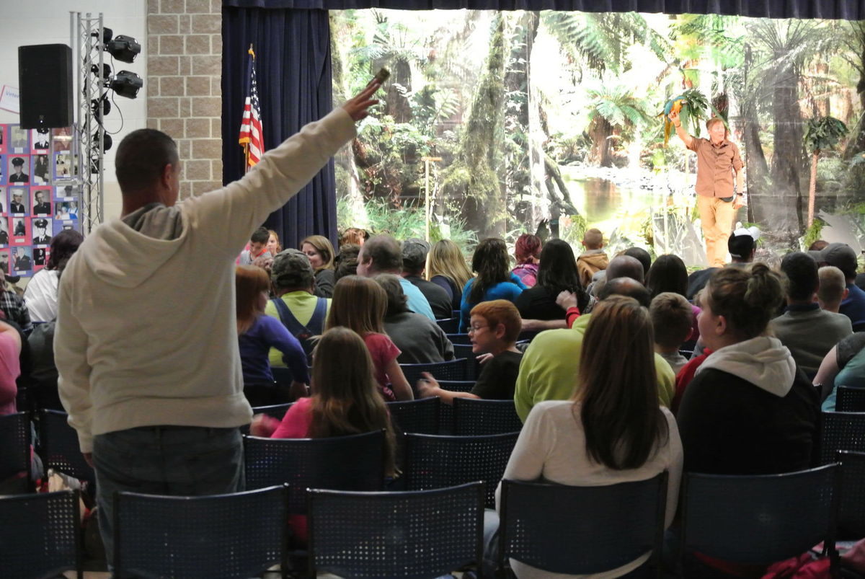](http://www.timesjournal.com/content/tncms/live/#21)

[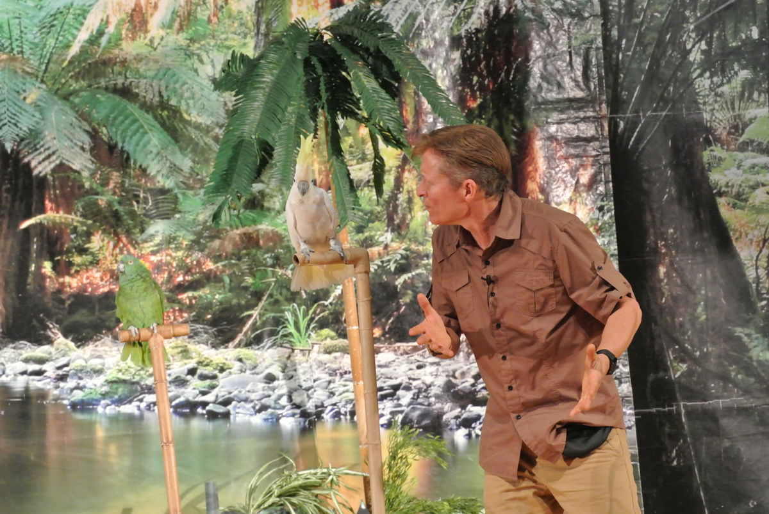](http://www.timesjournal.com/content/tncms/live/#25)[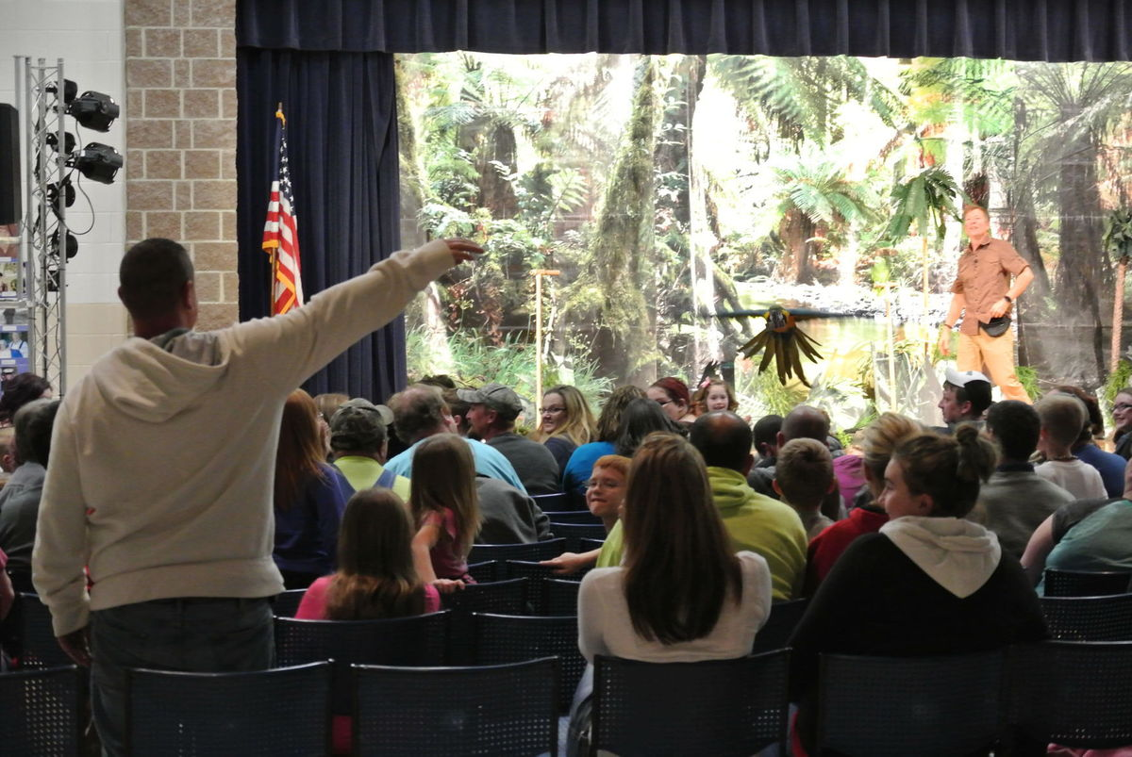](http://www.timesjournal.com/content/tncms/live/#23)

[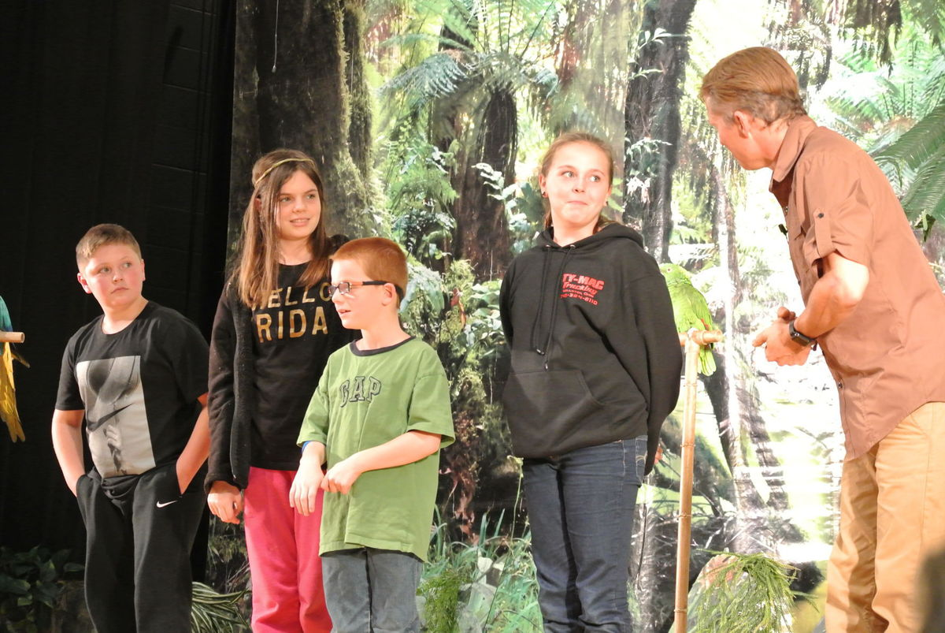](http://www.timesjournal.com/content/tncms/live/#28)[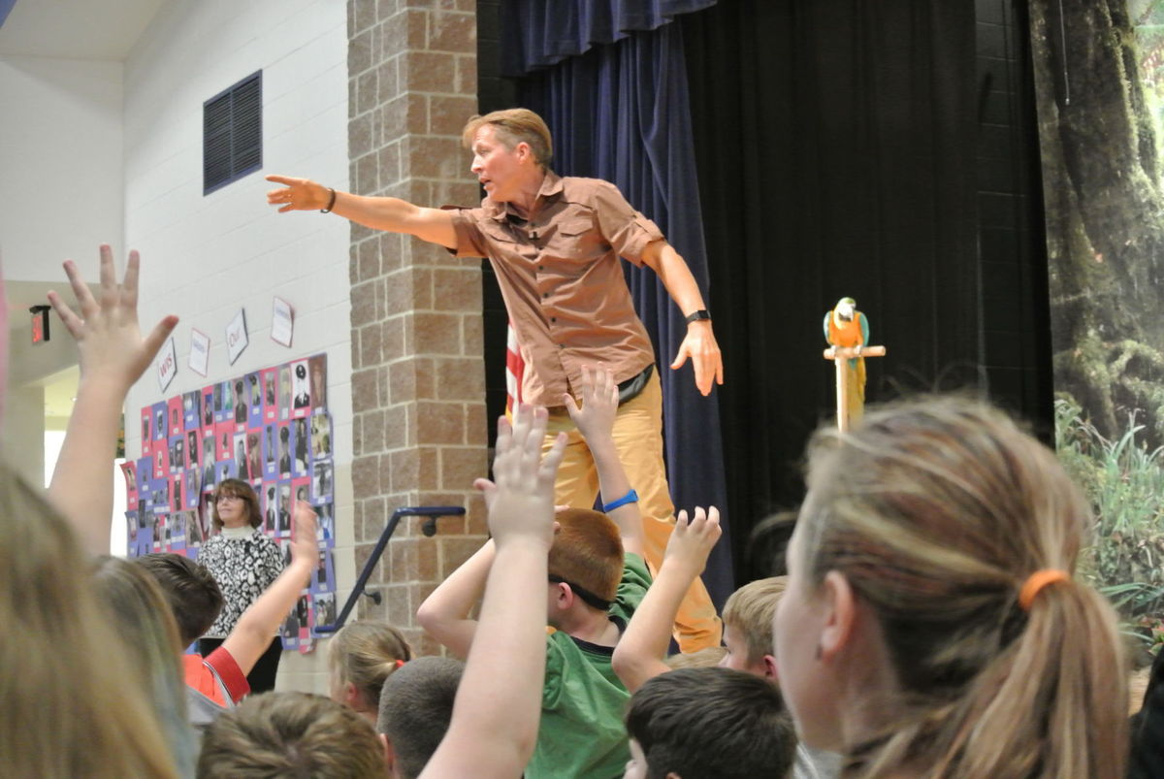](http://www.timesjournal.com/content/tncms/live/#27)

[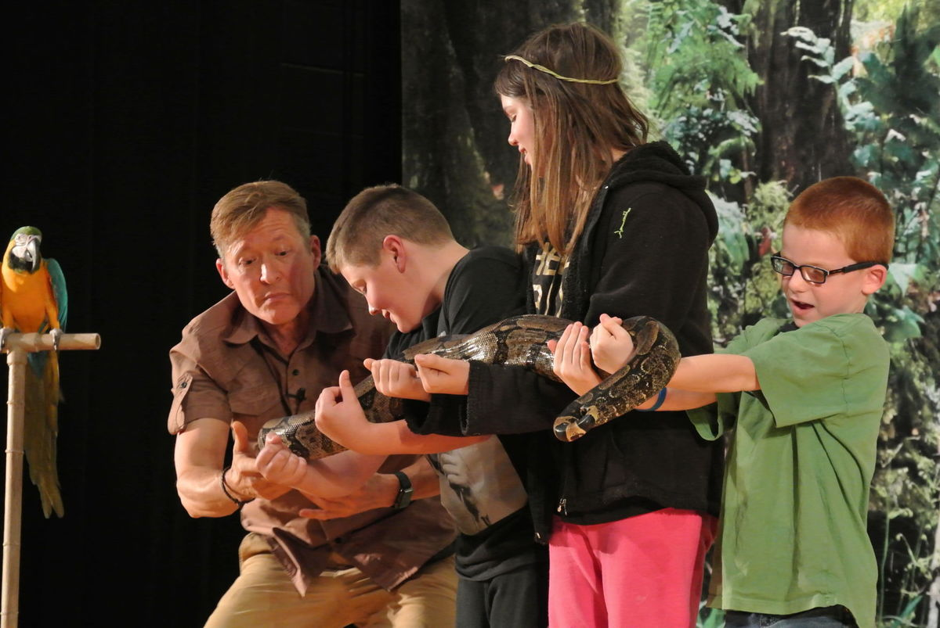](http://www.timesjournal.com/content/tncms/live/#29)

[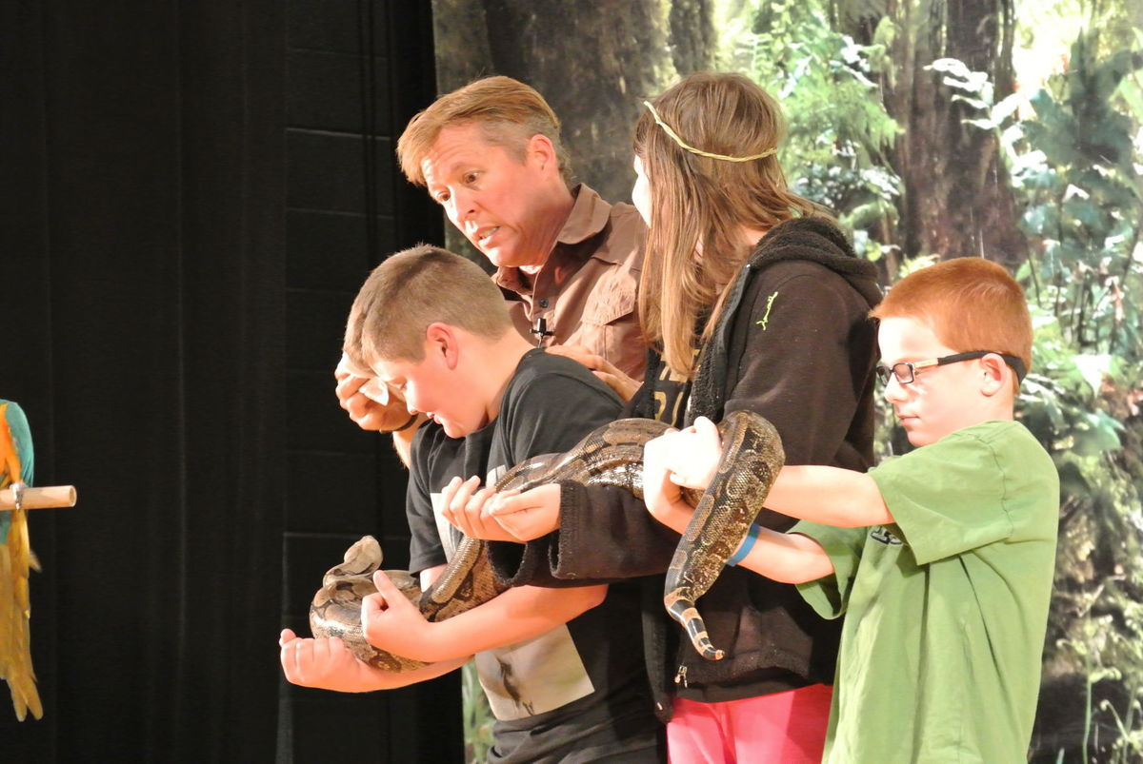](http://www.timesjournal.com/content/tncms/live/#30)

[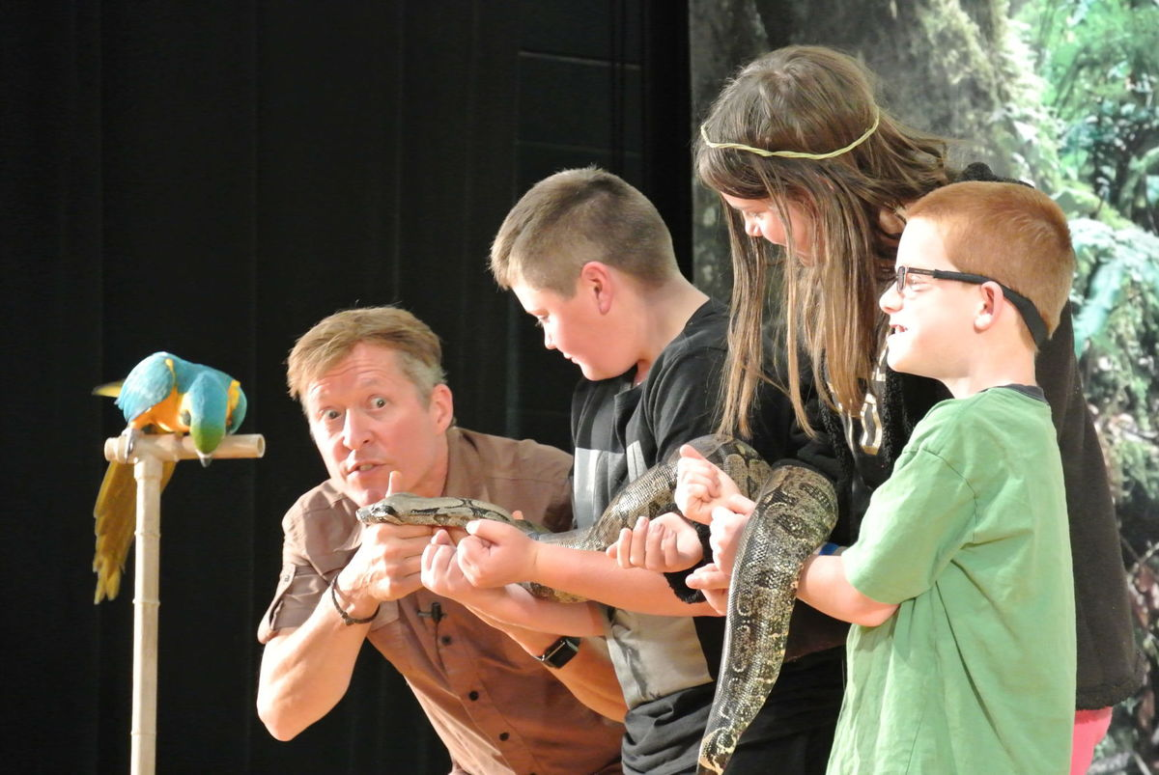](http://www.timesjournal.com/content/tncms/live/#31)

[](http://www.timesjournal.com/content/tncms/live/#33)

[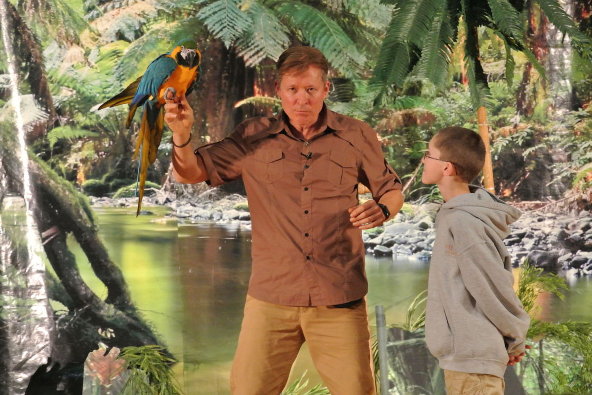](http://www.timesjournal.com/content/tncms/live/#35)

[](http://www.timesjournal.com/content/tncms/live/#37)

[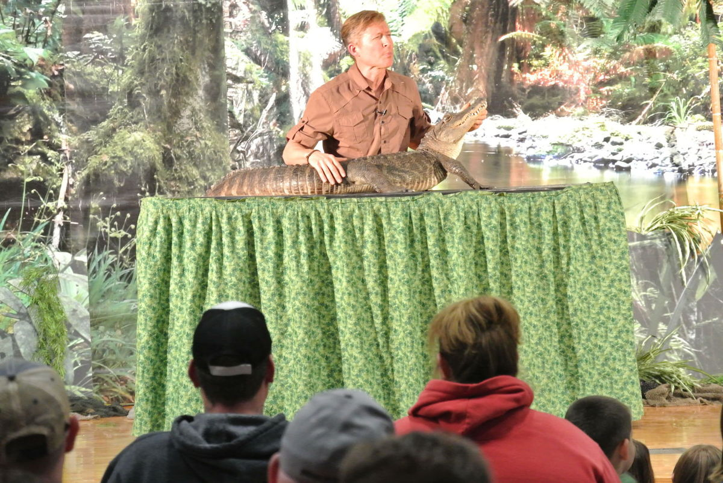](http://www.timesjournal.com/content/tncms/live/#39)

[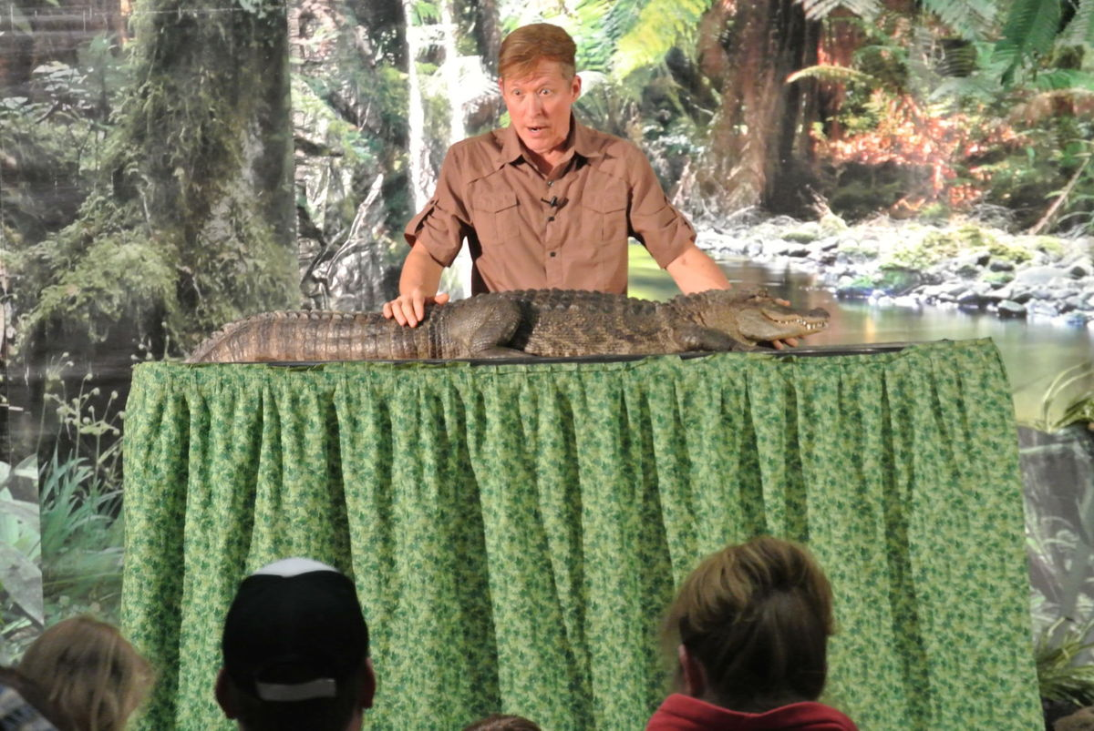](http://www.timesjournal.com/content/tncms/live/#41)

[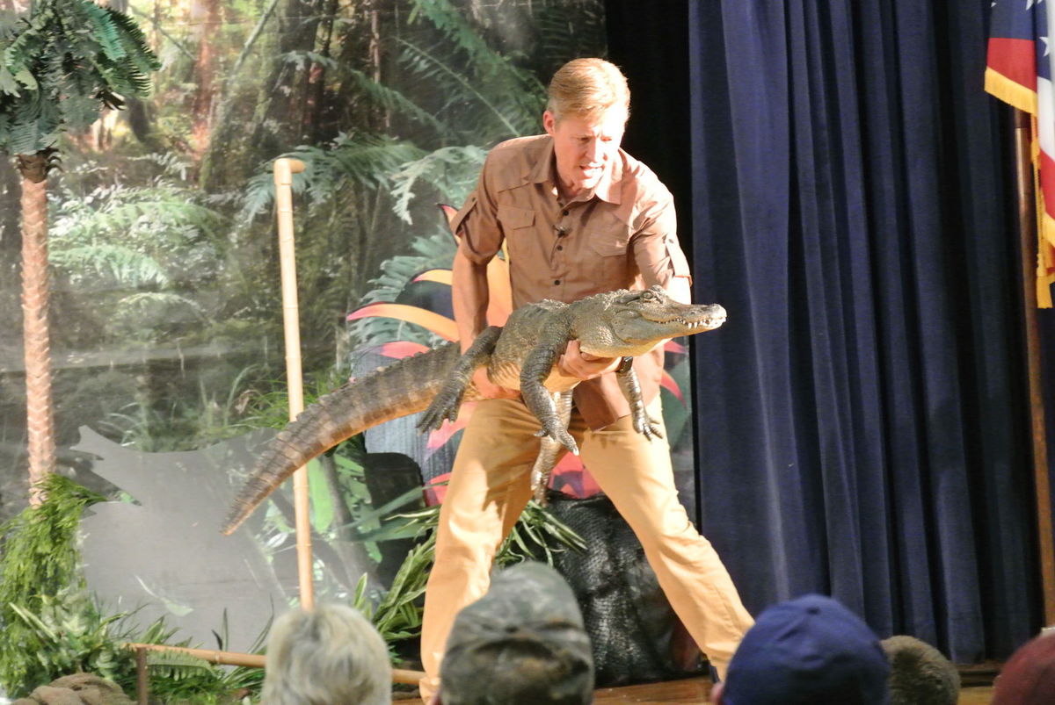](http://www.timesjournal.com/content/tncms/live/#42)

[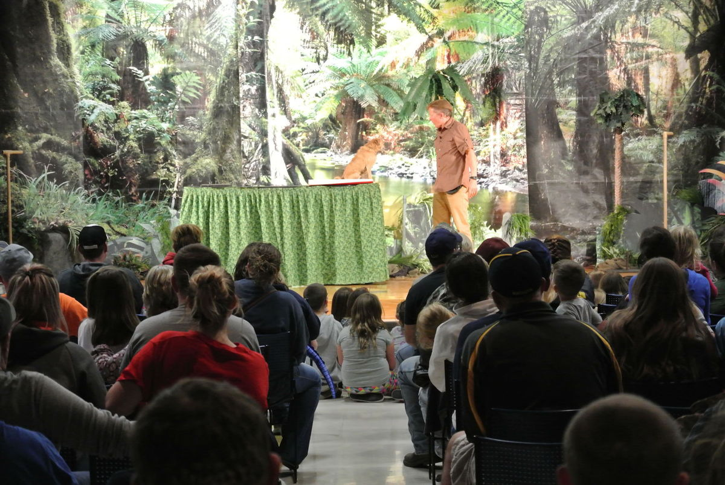](http://www.timesjournal.com/content/tncms/live/#43)

[](http://www.timesjournal.com/content/tncms/live/#44)

[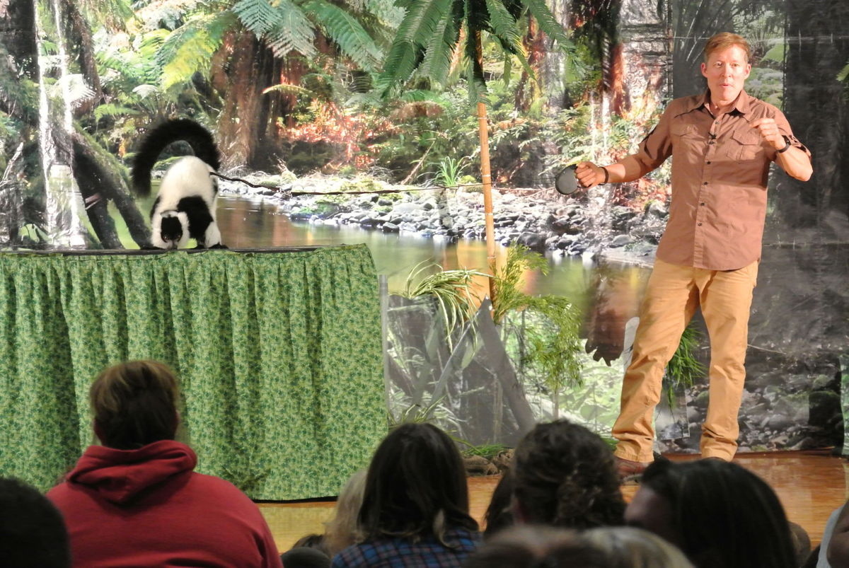](http://www.timesjournal.com/content/tncms/live/#45)

[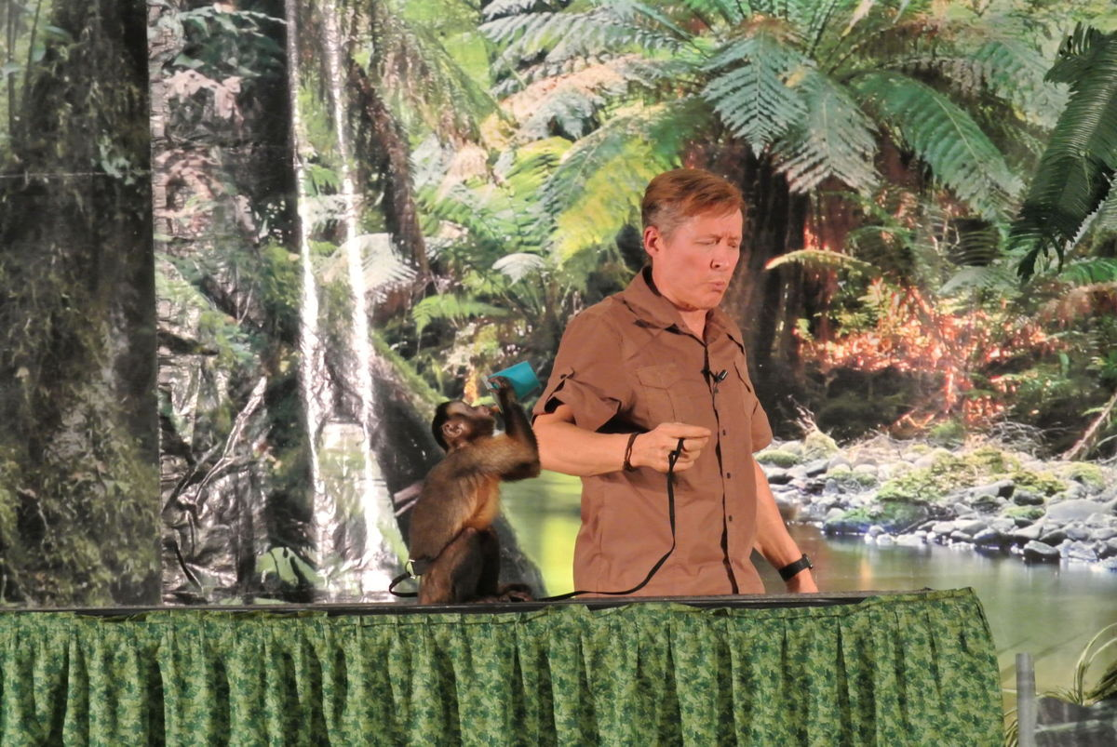](http://www.timesjournal.com/content/tncms/live/#46)

[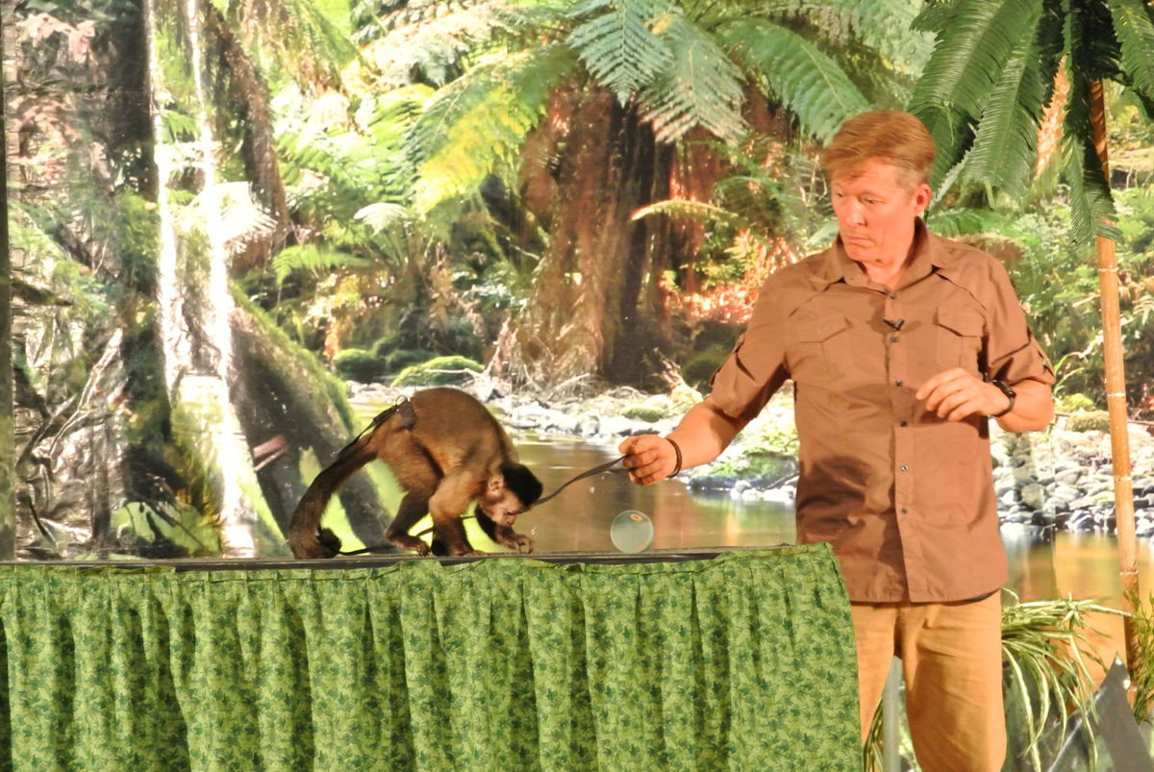](http://www.timesjournal.com/content/tncms/live/#47)

[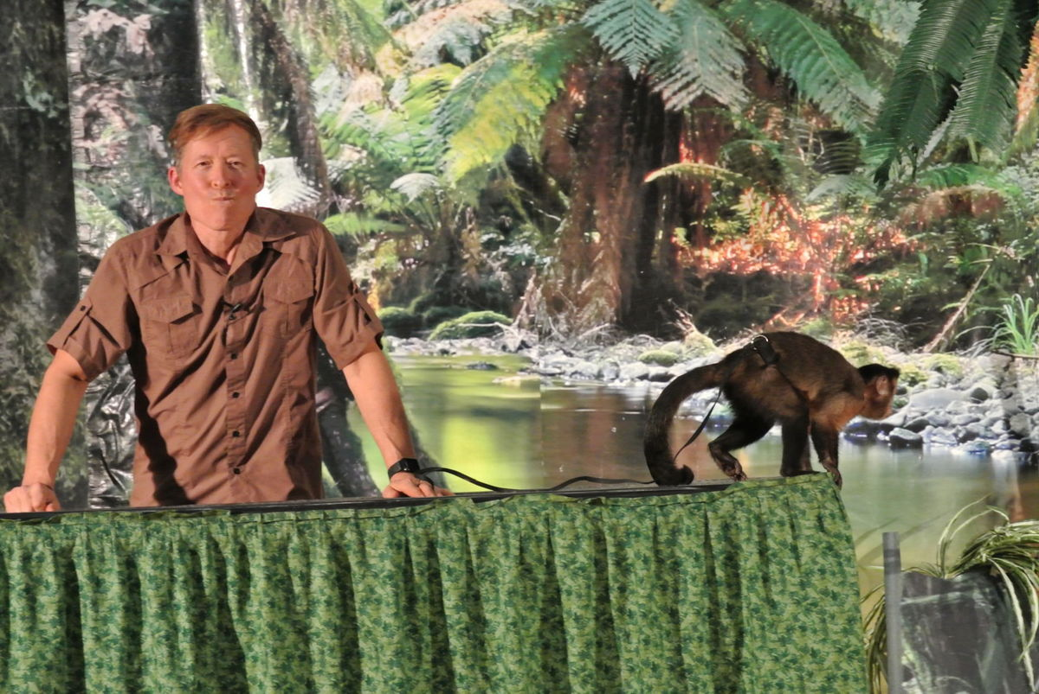](http://www.timesjournal.com/content/tncms/live/#48)

[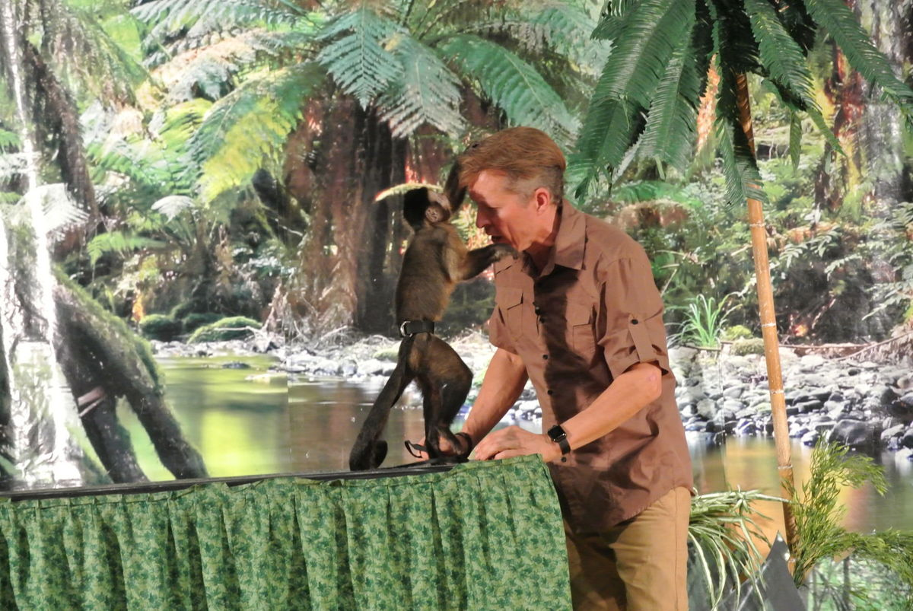](http://www.timesjournal.com/content/tncms/live/#49)

[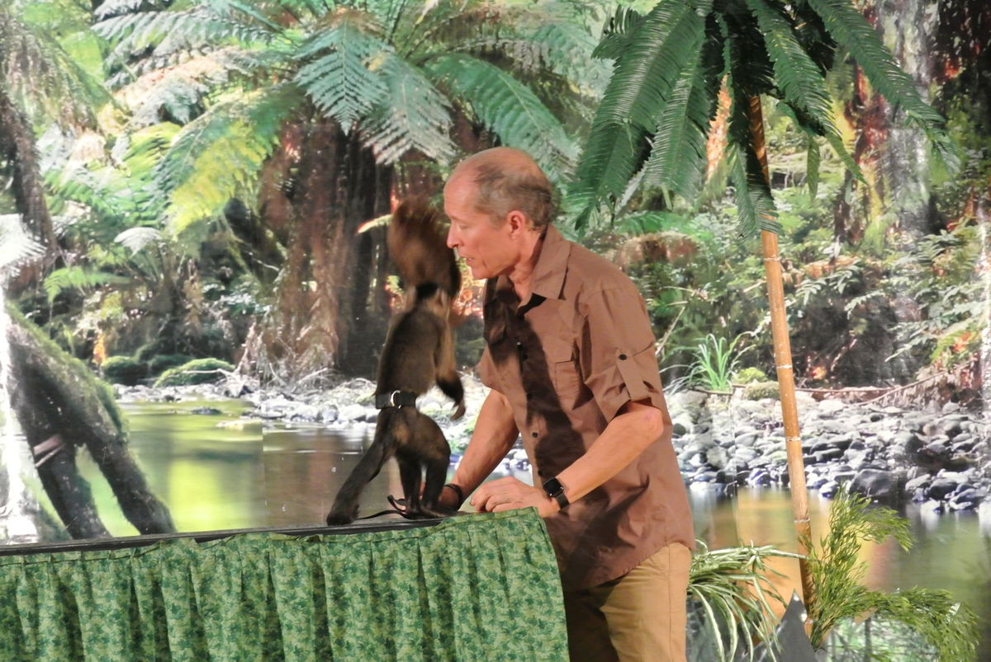](http://www.timesjournal.com/content/tncms/live/#50)