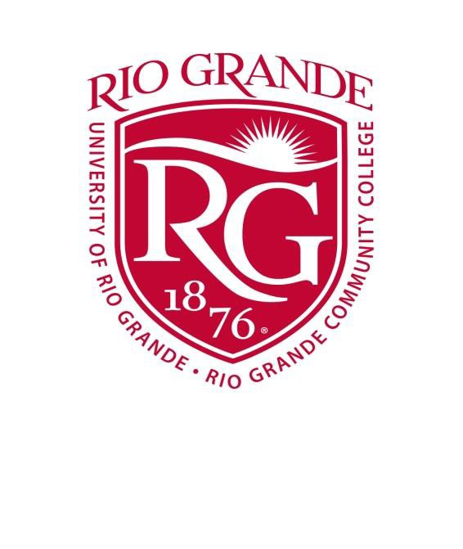Temporary

Special Event Visitor Parking Permit University of Rio Grande/Rio Grande Community College Permit #: VISITOR
Effective Dates: October 5, 2016
Start Time: 8:00 AM End Time: 4:00 PM

Event Name: Gallia-Vinton ESC Visitor
Event Location: Wood Hall/Learning Center
Lot Type: Wood Hall/LC

Campus Contact: Annette Ward Campus Contact Phone: 245-7252

Directions: Place this sign in plain view on the dash of the vehicle. Be sure the sign is still in view, on the dash, before leaving your vehicle.
Permission is for daytime parking only. No overnight parking. Park in a marked legal space in a student or employee parking lot.

Disclaimer: Lock all doors. Do not leave valuables in plain view. URG Disclaims all responsibility from losses or damages to vehicles parked on URG property. URG is not responsible for losses or damages to any vehicle towed from campus. If ordered to do so, vehicles must be moved in the event of a URG college need or emergency.

Contact campus Police at: 740-245-7286 Permit Created:
Chief Scott Borden, University of Rio Grande Campus Police Department

