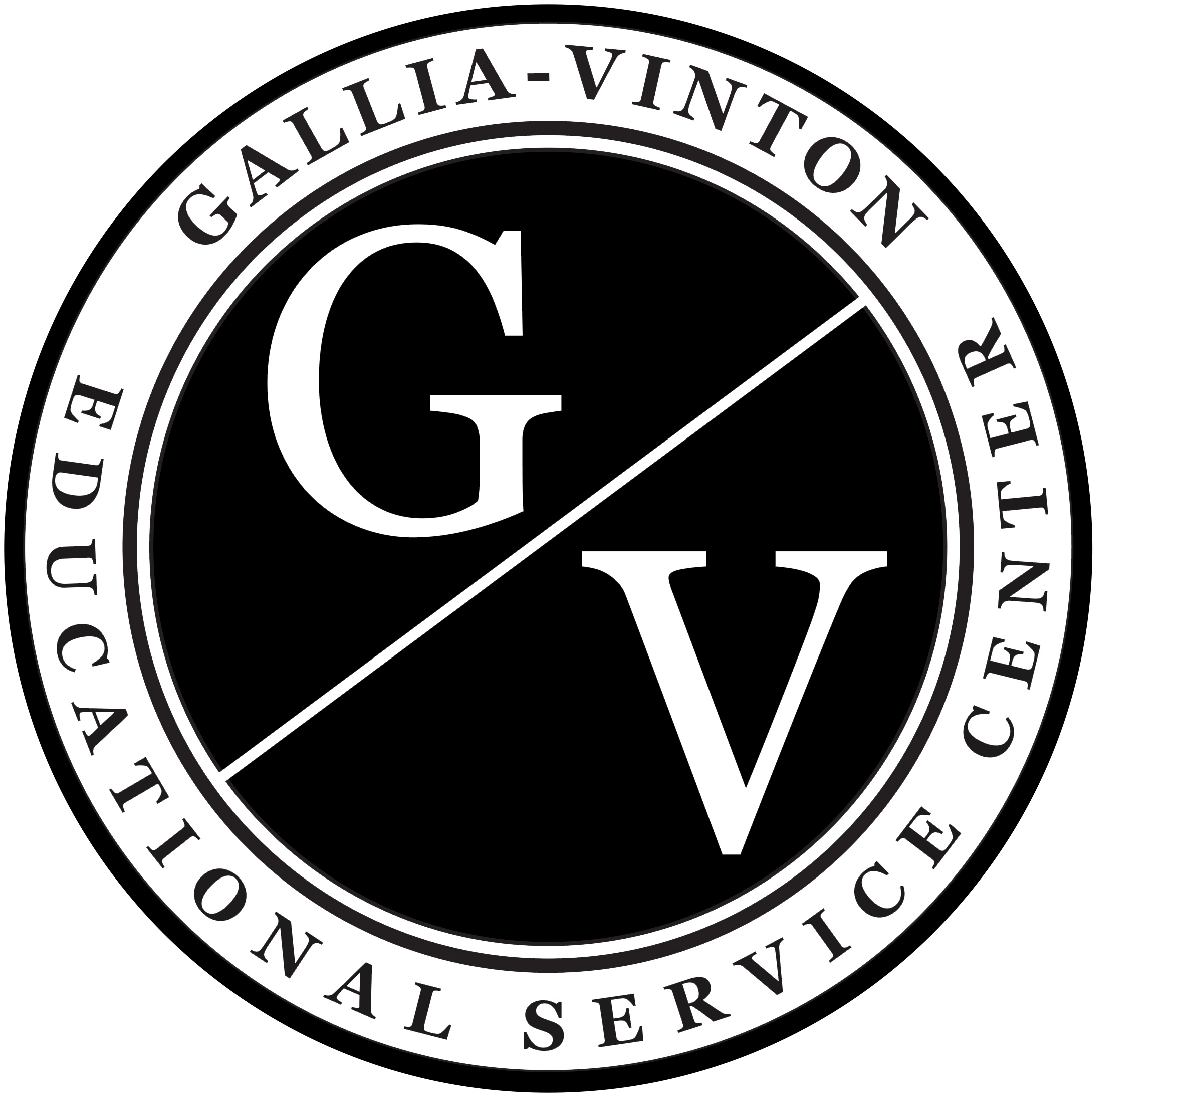  - Tests and good science teaching:  They can coexist!  A One-Day PD Workshop  This PD focuses on grades 5, 8, and biology. The test specifications, documents, and online testing materials contain valuable information which can guide high-quality classroom activities, instructional approaches, and assessment design. Participants will dig into these and related resources. Time during this session will be spent exploring resources and critiquing and sharing activities, performance tasks, and assessments to be incorporated in lessons used throughout the year. The structure will allow for targeted support in each tested area.  Empowering educators in their profession | Date: Friday, November 22nd  Time: 8:30 AM - 3:30 PM  Location: Gallia-Vinton ESC  Grades: 5, 8, and HS Biology  Cost: $25  Register: Visit the Upcoming Events page at www.galliavintonesc.org  Credit: 6 Contact Hours  Lunch and refreshments will be provided  Facilitator: David Vernot, Curriculum Consultant Butler County ESC  For more information email 90_jwhite@seovec.org
Contact us for more information about Gallia-Vinton Educational Service Center programs and services: P.O. Box 178, Wood Hall 131 • Rio Grande, OH 45674 • (740) 245-0593 • www.galliavintonesc.org

